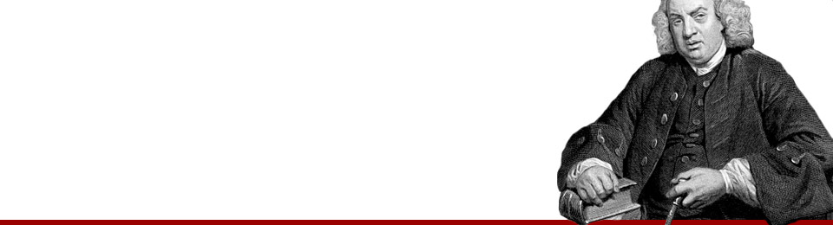

No. 91. Sufficiency of the English language.
12Jan 1760
Posted by Samuel Johnson in The Idler
≈ Comments Off on No. 91. Sufficiency of the English language.
It is common to overlook what is near, by keeping the eye fixed upon something remote. In the same manner present opportunities are neglected, and attainable good is slighted, by minds busied in extensive ranges, and intent upon future advantages. Life, however short, is made still shorter by waste of time, and its progress towards happiness, though naturally slow, is yet retarded by unnecessary labour.
The difficulty of obtaining knowledge is universally confessed. To fix deeply in the mind the principles of science, to settle their limitations, and deduce the long succession of their consequences; to comprehend the whole compass of complicated systems, with all the arguments, objections and solutions, and to reposite in the intellectual treasury the numberless facts, experiments, apophthegms and positions, which must stand single in the memory, and of which none has any perceptible connexion with the rest, is a task which, though undertaken with ardour and pursued with diligence, must at last be left unfinished by the frailty of our nature.
To make the way to learning either less short or less smooth, is certainly absurd; yet this is the apparent effect of the prejudice which seems to prevail among us in favour of foreign authors, and of the contempt of our native literature, which this excursive curiosity must necessarily produce. Every man is more speedily instructed by his own language, than by any other; before we search the rest of the world for teachers, let us try whether we may not spare our trouble by finding them at home.
The riches of the English language are much greater than they are commonly supposed. Many useful and valuable books lie buried in shops and libraries, unknown and unexamined, unless some lucky compiler opens them by chance, and finds an easy spoil of wit and learning. I am far from intending to insinuate, that other languages are not necessary to him who aspires to eminence, and whose whole life is devoted to study; but to him who reads only for amusement, or whose purpose is not to deck himself with the honours of literature, but to be qualified for domestick usefulness, and sit down content with subordinate reputation, we have authors sufficient to fill up all the vacancies of his time, and gratify most of his wishes for information.
Of our poets I need say little, because they are, perhaps, the only authors to whom their country has done justice. We consider the whole succession from Spenser to Pope as superior to any names which the continent can boast; and, therefore, the poets of other nations, however familiarly they may be sometimes mentioned, are very little read, except by those who design to borrow their beauties.
There is, I think, not one of the liberal arts which may not be competently learned in the English language. He that searches after mathematical knowledge may busy himself among his own countrymen, and will find one or other able to instruct him in every part of those abstruse sciences. He that is delighted with experiments, and wishes to know the nature of bodies from certain and visible effects, is happily placed where the mechanical philosophy was first established by a publick institution, and from which it was spread to all other countries.
The more airy and elegant studies of philology and criticism have little need of any foreign help. Though our language, not being very analogical, gives few opportunities for grammatical researches, yet we have not wanted authors who have considered the principles of speech; and with critical writings we abound sufficiently to enable pedantry to impose rules which can seldom be observed, and vanity to talk of books which are seldom read.
But our own language has, from the Reformation to the present time, been chiefly dignified and adorned by the works of our divines, who, considered as commentators, controvertists, or preachers, have undoubtedly left all other nations far behind them. No vulgar language can boast such treasures of theological knowledge, or such multitudes of authors at once learned, elegant and pious. Other countries and other communions have authors, perhaps, equal in abilities and diligence to ours; but if we unite number with excellence, there is certainly no nation which must not allow us to be superior. Of morality little is necessary to be said, because it is comprehended in practical divinity, and is, perhaps, better taught in English sermons than in any other books, ancient and modern. Nor shall I dwell on our excellence in metaphysical speculations, because he that reads the works of our divines will easily discover how far human subtilty has been able to penetrate.
Political knowledge is forced upon us by the form of our constitution; and all the mysteries of government are discovered in the attack or defence of every minister. The original law of society, the rights of subjects and the prerogatives of kings, have been considered with the utmost nicety, sometimes profoundly investigated, and sometimes familiarly explained.
Thus copiously instructive is the English language; and thus needless is all recourse to foreign writers. Let us not, therefore, make our neighbours proud by soliciting help which we do not want, nor discourage our own industry by difficulties which we need not suffer.

